**During ‘Separation’ Never:**

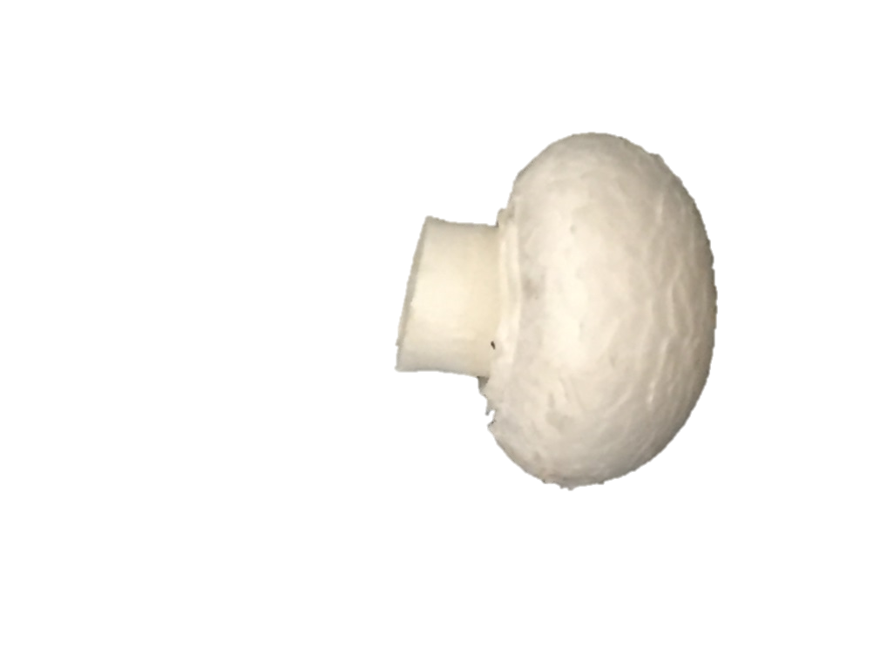**1.Pick ‘Principle Mushrooms’.**

**2.Pick mushrooms on the ‘Side of a Clump’.**

**3.Pick ‘Stand Alone Mushrooms’**

**Three key Elements are:**

**1.All ‘Clumps’ have been opened up by the ‘Separation’ process.**

**2.All ‘Principle’ mushrooms have been left for picking during later ‘Passes’.**

**3.The ‘Stagger’ from the initial pin set has been maintained.**